SNIGF/NILGS — MVP Technical Baseline v0.1
Oct 20, 2026 · @Pythagore

Status
This is a design baseline for review; no application code exists yet. Implementation (Task F) starts with the first vertical slice in Task E once the team answers the decisions in the last section.
- Everything here uses synthetic data and simulated decision authority. Nothing implies MINDCAF or government approval.
- Values marked DEMO (fees, deadlines, reference formats, document lists) are placeholders until validated by the team.
- Comment directly on any line you disagree with; I will revise and record the change as an architecture decision.

A. Understanding of the project
SNIGF/NILGS is a proposed land-governance platform for Cameroon; the MVP must prove one traceable journey from parcel record to authorized (simulated) decision, with conflicts surfaced and every step auditable. It is a case-management system wrapped around a cadastral index, not an ownership oracle: software records evidence and decisions, people with authority make them.

MVP boundary
In scope: parcel records with versioned geometry, one demo application type, document upload, completeness checking, overlap and duplicate alerts, review and simulated decision, applicant tracking, tamper-evident audit, and a simulated paid service.
Out of scope for the MVP: a legal rights register, certificate issuance, transfers, subdivision and merger, public notices and objections, field inspections, external integrations, legacy migration, real identity verification and real payments. The data model leaves room for each (Task D).

Actors
Actor | Role in the MVP | Notes
Applicant | Creates, submits and tracks own applications; uploads documents; pays the demo fee | Sees only own records
Representative | Acts for an applicant | Modelled as a field on the application; mandate verification is future
Intake officer | Checks completeness, requests missing information | Office-scoped
Cadastral officer | Creates and corrects parcel records; reviews spatial alerts | Cannot resolve alerts on parcel versions they created
Reviewer | Examines case file, records a recommendation | A recommendation is not a decision
Decision authority (simulated) | Records the outcome | Every decision is flagged simulated in the MVP
Supervisor | Sees workload, stage durations, overdue cases | Read-mostly
Auditor | Reads and verifies the audit trail | Cannot change business data
Finance officer | Reviews payment reconciliation exceptions
System administrator | Manages users and role assignments | Cannot grant roles to self or edit audit records
System | Runs completeness, geometry and overlap checks; receives simulated payment callbacks | Recorded as a service identity in audit

Concepts that must stay separate
Concept | What it is | What it is not
Parcel | A cadastral unit: stable reference plus versioned geometry and locality | Proof of ownership; it has no owner column
Application | A request for a service, with a lifecycle | A registered record or a right
Document | An uploaded file with category and checksum | Verified evidence; authenticity is a separate future check
Completeness result | Required fields and document categories present | An authenticity or eligibility finding
Conflict alert | A system signal: geometries overlap or references repeat | A finding of fraud or of competing rights
Claim | An asserted interest by a party in a parcel (future entity) | An established right
Review | An officer's finding and recommendation | A decision
Decision | An authorized outcome with grounds, actor and time; immutable | A registered right or a title
Registered right | A right entered in the legal register after decision (future) | Anything the MVP creates
Payment request / payment record | What is owed / what a channel reports as paid | Each other; they are matched by reconciliation

Gaps and contradictions found
- No registered-rights step, but a decision step. Recommendation: the MVP ends at a recorded, simulated decision. No rights register is built.
- Application type and required documents are unspecified. Provisional: one type, "Demande d'immatriculation (DEMO)", with three DEMO document categories.
- Coordinate reference system is not stated. Cameroon spans two UTM zones (32N and 33N). Provisional: store in EPSG:4326, accept EPSG:32632 and 32633 input, compute areas on the spheroid. The official national CRS and datum must be confirmed.
- When overlap detection runs. The journey places it after application submission, but it is a parcel property. Provisional: run on every parcel version write; an open alert on the linked parcel blocks the decision step.
- Payment timing. Not stated whether non-payment blocks processing. Provisional: payment must be confirmed before completeness can be accepted, behind a configuration flag.
- Separation-of-duties rules are not defined. Provisional rules: the decision authority cannot be the reviewer who recommended; an alert resolver cannot be the author of either compared parcel version; nobody assigns roles to themselves.
- "Administrators cannot rewrite audit" versus database superusers. The application can enforce this; a database superuser always can. The control is tamper evidence (hash chain plus externally kept checkpoints), and this residual risk is documented.
- Correction of a parcel is a negative-case requirement but correction workflows are out of scope. Provisional: support a direct, reasoned new parcel version by a cadastral officer; formal correction requests are future.
- Identity of applicants. No identity verification exists in the MVP; self-registered synthetic accounts only.
- Hosting, data residency and connectivity constraints are unknown. They do not block the MVP but shape the pilot architecture.

B. Architecture recommendation
Keep the proposed stack, built as one modular monolith with one PostgreSQL/PostGIS database and a same-origin web front end. It fits the domain (strong transactions, mature spatial SQL), is widely staffed, and runs on a single modest server for the demo. Two changes to the candidate list: no MinIO, and no JWT-based auth.
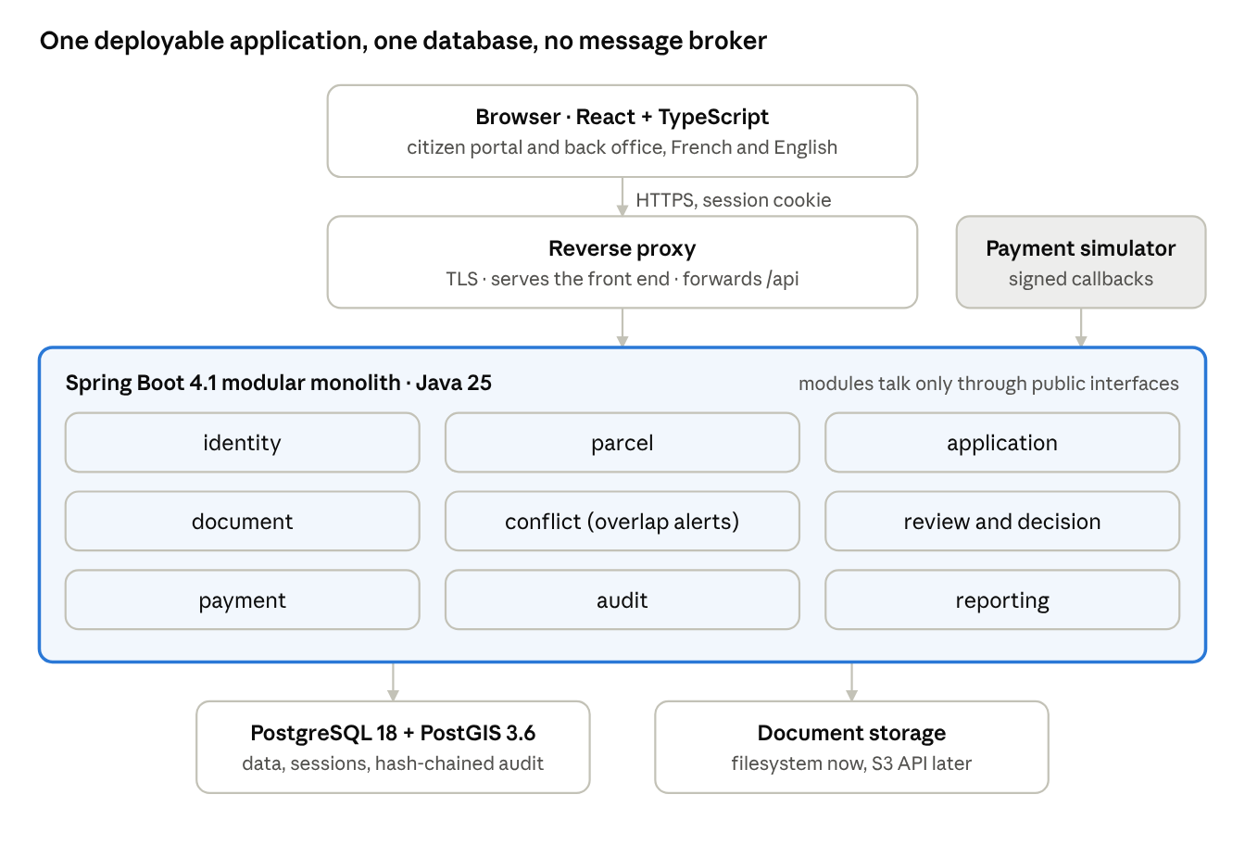
MVP deployment · one application, one database
Everything runs under Docker Compose on one host; only the reverse proxy is reachable from outside.

Versions (checked October 2026)
Component | Choice | Why
Runtime | Java 25 (LTS) | Long support window; required baseline of current Spring
Framework | Spring Boot 4.1.x | GA 10 June 2026; open-source support to 30 June 2027 (release notes, support dates). 4.0 support ends 31 Dec 2026
Database | PostgreSQL 18 + PostGIS 3.6.x | PostGIS 3.6.4 packaged for PG18 in June 2026 (package)
Front end | React + TypeScript, built with Vite | Exact versions pinned at scaffold time

Backend
- Modules (Spring Modulith, boundaries verified in a test): identity, parcel, application, document, conflict, review, payment, audit, reporting, shared. Modules call each other through public service interfaces only; no cross-module repository access.
- Persistence: Spring Data JPA with Hibernate Spatial (JTS) for writes; hand-written SQL for spatial queries so PostGIS does the geometry. Flyway for versioned migrations.
- State machines: explicit enum states plus a transition table in code, enforced in one service method and backed by a database check constraint. No workflow engine yet.
- API: REST under /api/v1, OpenAPI generated by springdoc, errors as RFC 9457 Problem Details with stable error codes (the front end translates codes, so the API stays language-neutral).
- Concurrency: optimistic locking (version column) on parcels, applications and alerts; 409 Conflict on stale writes. Idempotency-Key header on submission and payment endpoints.

Authentication and session model
- Spring Security with server-side sessions stored in PostgreSQL (Spring Session JDBC), HttpOnly + Secure + SameSite=Lax cookie, CSRF token. Sessions can be revoked instantly, which a JWT cannot do without extra machinery.
- Passwords hashed with Argon2id; login rate-limited per account and IP (Bucket4j, in-process).
- TOTP multifactor for officer, decision, auditor and admin roles; applicants optional. Flagged as a team decision because it adds demo friction.
- Keycloak or national identity federation is deferred to the pilot, when there is a real identity source to integrate.

Documents
- A DocumentStorage interface with a local-filesystem adapter for the MVP and an S3-API adapter written against the AWS SDK.
- Not MinIO: its community edition entered maintenance mode in December 2025 and the server repository was archived in April 2026 (timeline). Garage, SeaweedFS or a managed S3 service are evaluated before the pilot.
- Content-type detection by file signature (Apache Tika), PDF/JPEG/PNG only, 10 MB DEMO limit, SHA-256 per file, download only as attachment. Malware scanning (ClamAV) is a pilot requirement.

Front end
- React Router, TanStack Query for server state, React Hook Form + Zod, i18next with French and English bundles.
- MapLibre GL JS for display. Geometry entry in the MVP is by GeoJSON file or paste, not freehand drawing; drawing tools come later. The basemap provider must respect its tile usage policy.
- Citizen and back-office areas are separate route trees with separate layouts; the server authorizes every call regardless.

Testing, delivery and operations
- JUnit 5, Testcontainers with the PostGIS image (spatial tests run against real PostGIS, never H2), Spring Security Test, Modulith verification; Vitest + Testing Library; Playwright for the end-to-end demo script.
- CI on every push: build, tests, dependency vulnerability scan (OWASP Dependency-Check or Trivy), secret scan (Gitleaks).
- Docker Compose for local and demo: db, app, web (reverse proxy serving the built front end and proxying /api). TLS terminates at the proxy. The database port is never published outside the host.
- Actuator health, structured JSON logs carrying a correlation id, nightly pg_dump with a tested restore. Provisional demo targets: RPO 24 hours, RTO 4 hours.

Deliberately not in the MVP
Not introduced | Reason | Revisit when
Microservices, Kubernetes | One team, one database, no independent scaling need | Multiple teams or offices need independent deploys
Kafka or any broker | In-process domain events suffice; nothing consumes them externally | External integrations (Domain O)
Keycloak / separate IdP | No external identity source yet | National ID or SSO integration
Redis, caching layer | No measured performance problem | Profiling shows one
Camunda/Flowable | Fixed workflow for one application type | Workflows must be configurable (UC-181)
GeoServer, tile server | API returns GeoJSON for small parcel sets | Thousands of parcels on screen
Blockchain | A hash-chained audit table with external checkpoints gives tamper evidence at far lower cost | Never by default
GraphQL, event sourcing, CQRS | No requirement they solve

C. MVP technical specification
Each capability below lists who acts, the rules the server enforces, the flows, and acceptance criteria that become automated tests. Every write produces an audit event (MVP-07), so that is not repeated per item.

Application lifecycle
Applications move through nine states; only the transitions drawn below are legal, and the server rejects any other with 409 INVALID_TRANSITION.
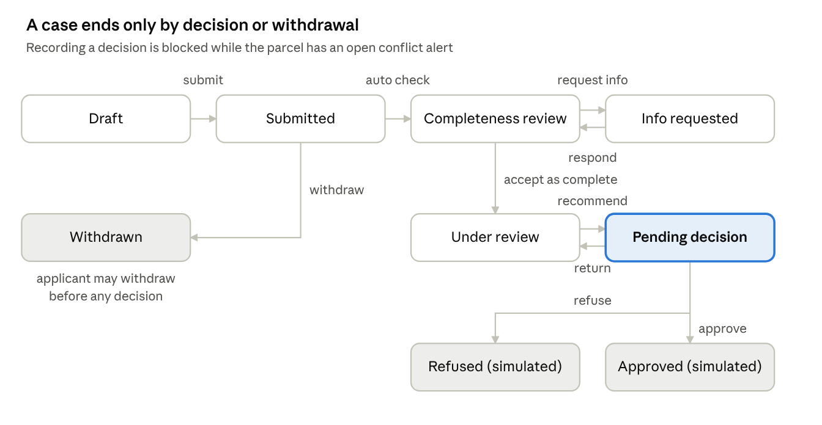
application lifecycle · 9 states
Information requests loop back to completeness review; the decision authority can return a case to review, but approved and refused are final in the MVP.

Permission matrix
Permission | Applicant | Intake | Cadastral | Reviewer | Decision | Supervisor | Auditor | Finance | Admin
parcel.create / parcel.correct |  |  | yes
parcel.read | linked only | yes | yes | yes | yes | yes | yes
application.create / submit / respond | own
application.read | own | office | office | assigned | assigned | office | yes
completeness.review / request-info |  | yes
alert.review / resolve |  |  | yes (SoD)
review.recommend |  |  |  | yes
decision.record |  |  |  |  | yes (SoD)
report.workload |  |  |  |  |  | yes
audit.read / verify |  |  |  |  |  | own office | yes
payment.pay (simulated) | own
payment.reconcile |  |  |  |  |  |  |  | yes
user.manage / role.assign |  |  |  |  |  |  |  |  | yes, never to self
Roles are scoped to an office; "office" means records whose application is assigned to the user's office.

MVP-01 Parcel creation and identification
- Actors: cadastral officer; any back-office role reads.
- Rules: reference generated by the server (format DEMO, see Task D), unique, never reused. Geometry must be Polygon or MultiPolygon, valid per ST_IsValid, with an explicit SRID in {4326, 32632, 32633}; it is transformed to 4326 for storage. Invalid geometry is rejected with the ST_IsValidReason text; it is never silently repaired. Verification status starts UNVERIFIED. A correction creates a new version with a mandatory reason; earlier versions are read-only.
- Normal flow: officer submits locality, optional external reference, GeoJSON → server validates, stores parcel + version 1, computes area in m², runs overlap detection (MVP-04) → returns reference and any alerts.
- Alternative flows: invalid geometry → 422 GEOMETRY_INVALID; unsupported or missing SRID → 422 CRS_UNSUPPORTED; non-officer → 403; stale version on correction → 409.
- Acceptance: valid parcel is retrievable by reference and renders on the map; a self-intersecting polygon is rejected with its reason; a UTM 33N input and its 4326 equivalent store the same geometry within 1 cm; a correction leaves version 1 readable and both versions in history; an applicant gets 403.

MVP-02 Application submission
- Actors: applicant (representative recorded as a field).
- Rules: one DEMO application type. Parcel link optional at draft, required at submit. Reference issued at submit, not at draft. Submission is idempotent per Idempotency-Key. Only the owner sees or edits it.
- Normal flow: create draft → fill fields → upload documents → submit → server runs completeness (MVP-03), creates payment request (MVP-08), sets SUBMITTED, returns reference.
- Alternative flows: submit with missing required data → 422 listing missing items, state stays DRAFT; another user's id in the URL → 404 (no existence leak); double submit with same key → same response, one application.
- Acceptance: reference unique and formatted; status history row written; applicant B cannot read applicant A's application.

MVP-03 Completeness checking
- Actors: system, intake officer, applicant.
- Rules: requirements are data (application type → required fields and document categories), versioned with effective dates. The check reports presence only. Officer outcomes: COMPLETE or INFO_REQUESTED with listed items and a message. Applicant's response adds documents as new versions; nothing is overwritten.
- Flows: officer opens the case, sees the automatic result, accepts (→ UNDER_REVIEW) or requests information (→ INFO_REQUESTED) → applicant responds (→ UNDER_COMPLETENESS_REVIEW). Accept is refused while required items are missing or (if the flag is on) payment is unconfirmed.
- Acceptance: missing category shows as missing; request-info round trip preserves both document versions; accept with missing items returns 409.

MVP-04 Duplicate and overlap detection
- Actors: system raises; cadastral officer reviews and resolves.
- Definitions (DEMO thresholds, configurable):
  - Overlap: interiors intersect (ST_Relate pattern T********) and intersection area ≥ 1 m², computed on the spheroid. Parcels that only share a boundary or a point are not flagged.
  - Possible duplicate geometry: overlap where intersection ≥ 95% of each parcel's area.
  - Duplicate reference: same normalised external reference on two active parcels.
- Rules: compares the new version against current versions of active parcels via GiST index. One open alert per parcel pair. The alert stores both version ids, the intersection area, both percentages and the intersection geometry as evidence. Resolution options: NO_CONFLICT, DATA_ERROR_CORRECTED, REFERRED_FOR_ADJUDICATION, each with a mandatory note. An open alert on an application's parcel blocks the decision.
- Acceptance: synthetic fixture set (Task D) yields exactly its expected alerts; touching parcels yield none; the resolver cannot be either version's author.

MVP-05 Review and decision
- Actors: reviewer, decision authority (simulated).
- Rules: reviewer records finding + recommendation (RECOMMEND_APPROVAL, RECOMMEND_REFUSAL, RETURN_FOR_INFORMATION) → PENDING_DECISION. Decision authority records APPROVED or REFUSED with grounds and cited document versions; must differ from the reviewer; decision rows are insert-only and carry simulated = true. Decision authority may return the case to UNDER_REVIEW.
- Acceptance: decision without grounds → 422; reviewer recording a decision → 403; decision on an INFO_REQUESTED case → 409; the UI and any printout state "Simulated decision — no legal effect".

MVP-06 Tracking and reporting
- Applicant view: current state, date entered, public-safe message, pending requests. Internal notes and reviewer identities are hidden.
- Back office: queue by state and office, time in current stage, overdue flag against DEMO stage targets (for example 5 days for completeness), counts per state.
- Acceptance: stage durations derive from the transition table, not edited fields; the applicant API response contains no internal fields (tested by schema).

MVP-07 Audit trail
- Rules: actor taken from the authenticated session, never the request body. Business change and its audit event commit in one transaction; denied attempts (403) are logged in their own transaction. The application database role can insert and read audit rows, never update or delete. Each row carries a SHA-256 hash chained to the previous row; the auditor's verify action recomputes the chain.
- Acceptance: each action in the demo script yields its expected event; a manual UPDATE by the application role fails; a tampered row is detected by verify; a supervisor can reconstruct a case's timeline from audit alone.

MVP-08 Paid-service workflow
- Rules: fee schedule rows have amount (XAF, integer), effective dates and the label "DEMO platform service charge — not an official administrative fee". Submission creates a payment request with a unique payment reference. A simulated provider posts signed (HMAC) callbacks; each provider transaction id is processed once. Reconciliation matches callback to request by reference and amount.
- Outcomes covered: paid and matched; failed; pending then expired; duplicate callback (ignored, logged); unmatched reference; amount mismatch (exception for finance officer).
- Acceptance: each outcome above is a passing test; no real payment API is called in any profile.

D. Initial domain model
Seventeen business tables cover the MVP; history is kept by append-only version and transition tables rather than by updating rows in place. All primary keys are UUIDv7 (time-ordered, not guessable); human-facing references are separate unique columns.

Entities built in the MVP
Module | Table | Purpose | Key constraints
identity | office | Organisational unit (DEMO offices) | unique code
identity | app_user | Account; Argon2id hash; MFA secret encrypted | unique lower(email); enabled
identity | role_assignment | User × role × office, with granted_by and dates | granted_by <> user_id check; unique active (user, role, office)
parcel | parcel | Stable identity: reference, status, current version | unique reference; status in (ACTIVE, SUPERSEDED, RETIRED); version for optimistic lock
parcel | parcel_version | Append-only geometry and attributes per change | unique (parcel_id, version_no); geom geometry(MultiPolygon,4326) NOT NULL with ST_IsValid check; GiST index; source_srid, area_m2, verification_status, change_reason, created_by
conflict | conflict_alert | Overlap or duplicate signal between two parcel versions | parcel_a_id < parcel_b_id; partial unique index on (pair, type) where status is open; stores intersection metrics and geometry
application | application_type | DEMO service catalogue, requirements as versioned JSON | unique code + effective_from
application | application | The request: applicant, parcel, type, state, office | unique reference (nullable until submit); state check constraint; version
application | application_transition | Every state change: from, to, actor, reason, time | append-only; FK to application
document | document | Logical document: application, category | FK; category check
document | document_version | Each uploaded file | storage key, SHA-256, size, detected MIME, status (PENDING, STORED, REJECTED); append-only
review | review | Completeness or substantive finding + recommendation | FK application; enum recommendation
review | decision | Simulated authorized outcome | unique per application; simulated NOT NULL with check = true; insert-only
payment | fee_schedule | DEMO charge per service with effective dates | exclusion constraint: no overlapping date ranges per service
payment | payment_request / payment_record | What is owed / what the channel reported | unique payment_reference; unique (provider, provider_txn_id) on records
audit | audit_event | Append-only, hash-chained log | no UPDATE/DELETE grant; trigger rejects both

Identifiers (DEMO formats)
- Parcel: DEMO-PCL-{office}-{yyyy}-{seq6}-{check}, for example DEMO-PCL-YDE1-2026-000042-K. The check character (ISO 7064 mod 37,36) catches mistyping. The real national scheme replaces this once defined; the column and uniqueness rule do not change.
- Application: DEMO-APP-{yyyy}-{seq6}-{check}. Payment: DEMO-PAY-{yyyy}-{seq8}-{check}.
- Sequences come from PostgreSQL sequences per prefix and year, so gaps are possible and acceptable; uniqueness is guaranteed by constraint, not by the generator.

Spatial data strategy
- Storage: EPSG:4326, MultiPolygon only (single polygons promoted). The input SRID and a hash of the original GeoJSON are kept for provenance.
- Validation order: parse → SRID present and supported → type check → ST_IsValid (reject with reason) → non-empty, area > 0 → transform → re-check validity after transform.
- Precision: coordinates snapped to 1e-7 degrees (about 1 cm) with ST_ReducePrecision before storage, so tests are deterministic.
- Area and overlap metrics: computed as ST_Area(geography) on the spheroid, in m², which avoids choosing between UTM 32N and 33N for parcels near the zone boundary.
- Candidate search: ST_Intersects on the GiST index first, then the exact ST_Relate and area test on candidates only.
- History: geometry is never updated; a correction is a new parcel_version. A future parcel_lineage table (parent, child, kind) represents subdivision and merger without touching existing rows.
- Test fixtures: eight synthetic parcels near a fictional locality with known outcomes: clean, touching edge, touching corner, 0.5 m² sliver (below threshold), 30% overlap, 98% duplicate, self-intersecting (invalid), and a UTM 33N copy of a 4326 parcel.

Audit model
- Columns: id, seq (bigserial), occurred_at (database clock), actor_type (USER or SERVICE), actor_id, actor_roles, action, entity_type, entity_id, outcome (SUCCESS, DENIED, FAILED), reason, correlation_id, details (JSON, no document contents or passwords), prev_hash, hash.
- hash = SHA-256(prev_hash || canonical row), computed in a BEFORE INSERT trigger under a transaction-scoped advisory lock. This serialises audit writes, acceptable at MVP volume.
- The head hash is exported daily to a location the database administrator cannot write (DEMO: a signed file sent to the auditor), so a full rewrite by a superuser is detectable.
- Three database roles: snigf_migrator owns the schema, snigf_app has least privilege (no DDL, no audit update or delete), snigf_auditor is read-only.

Extension points, not built
Future entity | Attaches to | Domain
party, claim | parcel, application | G competing claims
document_verification | document_version | D authenticity
registered_right, right_history | parcel, decision | H legal register
parcel_lineage | parcel | C subdivision and merger
public_notice, objection | application | G
field_inspection | parcel, application | F
admin_area (official geography) | parcel_version | C UC-037
import_batch, source_reference | parcel, document | P migration

E. Implementation backlog
The first vertical slice is "a cadastral officer records a parcel, sees it on the map, and the action is audited" (tasks E-01 to E-08). It touches every layer — login, permission check, PostGIS validation, migration, audit trigger, React map, tests — while staying small enough to review in one sitting. Overlap detection follows as slice 2 because it builds directly on stored geometry.
ID | Task | Depends on | Deliverable | Tests
E-01 | Repository, build, Compose skeleton, CI | — | Maven multi-module or single module with Modulith; Vite app; docker compose up gives db + app + web | CI green; container health checks
E-02 | Database roles and first migrations | E-01 | Three DB roles; office, app_user, role_assignment, audit_event with hash trigger | Testcontainers: app role cannot UPDATE/DELETE audit; chain verifies
E-03 | Authentication | E-02 | Session login/logout, Argon2id, CSRF, rate limit, seeded synthetic users | Wrong password, lockout, logout invalidates session, CSRF required
E-04 | Authorization framework | E-03 | Permission checks per endpoint, office scoping, denied-attempt audit | Matrix tests: each role × parcel endpoints
E-05 | Parcel create and read API | E-04 | parcel, parcel_version migrations; validation pipeline; reference generator | 8 geometry fixtures; CRS equivalence; 403 for applicant
E-06 | Audit integration | E-05 | Audit events for create/read-denied; auditor read + verify endpoint | Event per action; tamper detection
E-07 | Front end shell + login + i18n | E-03 | Layouts, FR/EN switch, error and permission-denied states | Vitest component tests
E-08 | Parcel screens | E-05, E-07 | Create from GeoJSON, detail with MapLibre map, version history | Playwright: create, view, invalid geometry message
E-09 | Parcel correction | E-08 | New version with reason; history view | Old version unchanged; optimistic-lock 409
E-10 | Overlap and duplicate detection | E-05 | Detection on version write; conflict_alert | Fixture outcomes exactly as expected
E-11 | Alert review screens | E-10 | Alert list, side-by-side map with intersection, resolution with SoD | Author cannot resolve; note required
E-12 | Application type, draft, submit | E-04 | Demo type, draft CRUD, submit with reference and idempotency | IDOR tests; double submit
E-13 | Documents | E-12 | Upload, signature-based type check, versions, download | Disguised file rejected; orphan cleanup
E-14 | Completeness review and info requests | E-13 | Auto check, officer accept/request, applicant response | Round trip keeps history; invalid transitions 409
E-15 | Review and simulated decision | E-14, E-11 | Recommendation, decision with SoD and alert gate | Same person blocked; open alert blocks
E-16 | Tracking and workload report | E-14 | Applicant timeline; supervisor queue and stage durations | Applicant payload has no internal fields
E-17 | Simulated payment | E-12 | Fee schedule, request, signed callback endpoint, reconciliation | Six payment outcomes
E-18 | Audit timeline view | E-06, E-15 | Case and parcel reconstruction screen for auditor/supervisor | Demo script events all present
E-19 | End-to-end demo script | all | Playwright run of the 11 steps and 7 negative cases | Full suite green in CI
E-20 | Operations pack | E-19 | Backup/restore script and drill, runbook, known-limitations doc | Restore into empty DB passes smoke tests

Slice 1 acceptance criteria
- ☐ docker compose up on a clean machine starts the stack; documented in the README.
- ☐ Seeded cadastral officer logs in, creates a parcel from a GeoJSON file, receives a reference, sees the polygon on the map.
- ☐ A self-intersecting polygon is rejected with a readable FR/EN message.
- ☐ A seeded applicant calling the create endpoint receives 403, and the denial is in the audit log.
- ☐ The auditor can list the events and run chain verification; a manually altered row fails verification.
- ☒ All tests above run in CI against PostGIS in Testcontainers.

Decisions needed from the team
I will proceed with the recommended default on each item unless you say otherwise; items 1–4 affect slice 1.
- ☐ Hosting for the demo: a single VPS or an institution-provided server? Determines TLS and backup setup. Default: one Linux VM with Docker Compose.
- ☐ Git hosting and CI: GitHub, GitLab, or other? Default: GitHub with Actions.
- ☐ MFA for back-office roles in the demo: on or off? Default: on, TOTP.
- ☐ Official CRS and datum used by Cameroonian cadastral services. Default: EPSG:4326 storage, 32632/32633 input.
- ☐ Demo application type and required document categories. Default: one title-registration-style type with three DEMO categories.
- ☐ Does unpaid status block completeness acceptance? Default: yes, behind a flag.
- ☐ Separation-of-duties rules in gap 6 of Task A: confirm or amend.
- ☐ Overlap thresholds: 1 m² minimum and 95% for duplicates. Confirm or supply surveyor guidance.
- ☐ Single-module or multi-module Maven build. Default: single module with Modulith-enforced packages.
Decisions above were approved on 20 October 2026 with clarifications; the resulting design is in Slice 1 design.

